Terms and conditions
Consultations
- We will have an initial consultation in which I will do an assessment. We will then discuss options open to you if you decide that we can work together. We will decide together on the number and frequency of appointments.
- Sessions are 50 minutes in duration.
- Consultations will be conducted in one of the following ways:
- In person at my office
- Online using Skype (voice or video), WhatsApp (voice or video), Zoom (voice or video) or telephone.
In-person sessions
- There is no waiting room at this practice. Kindly arrive on time for your appointment.
- If you are early, please wait in your car until the time of your appointment.
- The practice does not accept liability for any injury or damage to person or property for whatever reason before, during or after the session while on the premises.
Online and telephonic sessions
- I will wait 10 minutes from the start of the session for you to connect online. After this time I will accept that you have failed to show for your appointment.
- This service is not suitable for suicide emergencies.
- In order to get maximum benefit from the consultation please ensure you are seated in a safe, private space where you will not be disturbed during consultation.
- Neither party has permission to make digital recordings of the session.
- In case of technical problems:
- If you are experiencing technical problems and cannot connect with me, please make contact with me so that we can make alternative arrangements.
- If you fail to show online and don’t make contact, you will be charged for the full session.
- If I cannot get online and connect with you, I will contact you to make alternative arrangements or reschedule.

Payment
- Clients will receive an invoice on the 25th of each month for the total sessions done. Payment is due on that day.
- Payments can be made using EFT, PayPal or cash.
- Your name is used as reference.
- In the case of non-payment, incidental interest of 2% per month will be charged until payment received.

Cancellations, missed and late sessions
- You will be expected to provide at least 24 hours notice if you cannot make an appointment. If you cancel your appointment within the 24 hour period, I reserve the right to bill you for the full session. Exceptions can be made due to severe circumstances.
- If you arrive late for your session, I reserve the right to finish the session at the correct time to make sure that following appointments are not impacted.
- If you fail to attend your appointment, I reserve the right to bill you for the full session.

Confidentiality
- Confidentiality is an integral part of counselling and is seen as essential to building the counsellor-client relationship. This ensures a sense of safety. This process encourages the client to be as open and honest as possible. Your experiences and personal sensitive information can be disclosed with ease of mind.
- It is vital that you trust that everything that is discussed will remain completely confidential. The only circumstances where confidentiality would not apply is when there is a serious risk to your life, the the life of someone else or if the counsellor is asked to participate in civil or criminal court proceedings.
- If it is believed that there is any risk to your life or well-being, I reserve the right to contact your doctor (GP) or next of kin.
- Your case may be discussed with a supervisor, but all personal particulars will be withheld and you will therefore remain anonymous.

Legal recourse
- I am registered with the Health Professions Council of South Africa (HPCSA) as a Registered Counsellor (Registration: SRC 0029661) and my professional behaviour is governed by this regulatory body.

Contact details:
Full name: ……………………………………………………………………………………………
Date of birth: …………………………………….. Age: …………………………………………..
Identity number: ……………………………………………………………………………………
Home address: ……………………………………………………………………………………
……………………………………………………………………………………
Postal address: ……………………………………………………………………………………
………………………………………. Post / Zip code ………..………………
Home number: …………………………………………. Work number: ……………………….
Mobile number: …………………………………………
E-mail address: …………………………………………
Occupation: ……………………………………………..
Medical Aid:
Name of medical Aid: ……………………………………………………………………………….
Number: ……………………………………………………………………………….
Name of main member: …………………………………………………………………………….
Person to contact in the event of an emergency:
Name and relationship to you: …………………………………………………………………….
Telephone numbers: .……………………………………………………………………………….

Declaration by client (or parent if younger than 12)
This section must be completed by the person undergoing counselling.
I,……………………………………………………………………………………. (Full name)
- Have understood the practice details, policies and contract above and accept all the conditions thereof.
- I agree that this contract constitutes a binding agreement between us.
- I agree to pay all legal costs in the event of legal proceedings due to my not keeping this agreement.
- I agree to settle my account in full upon receipt of the invoice.

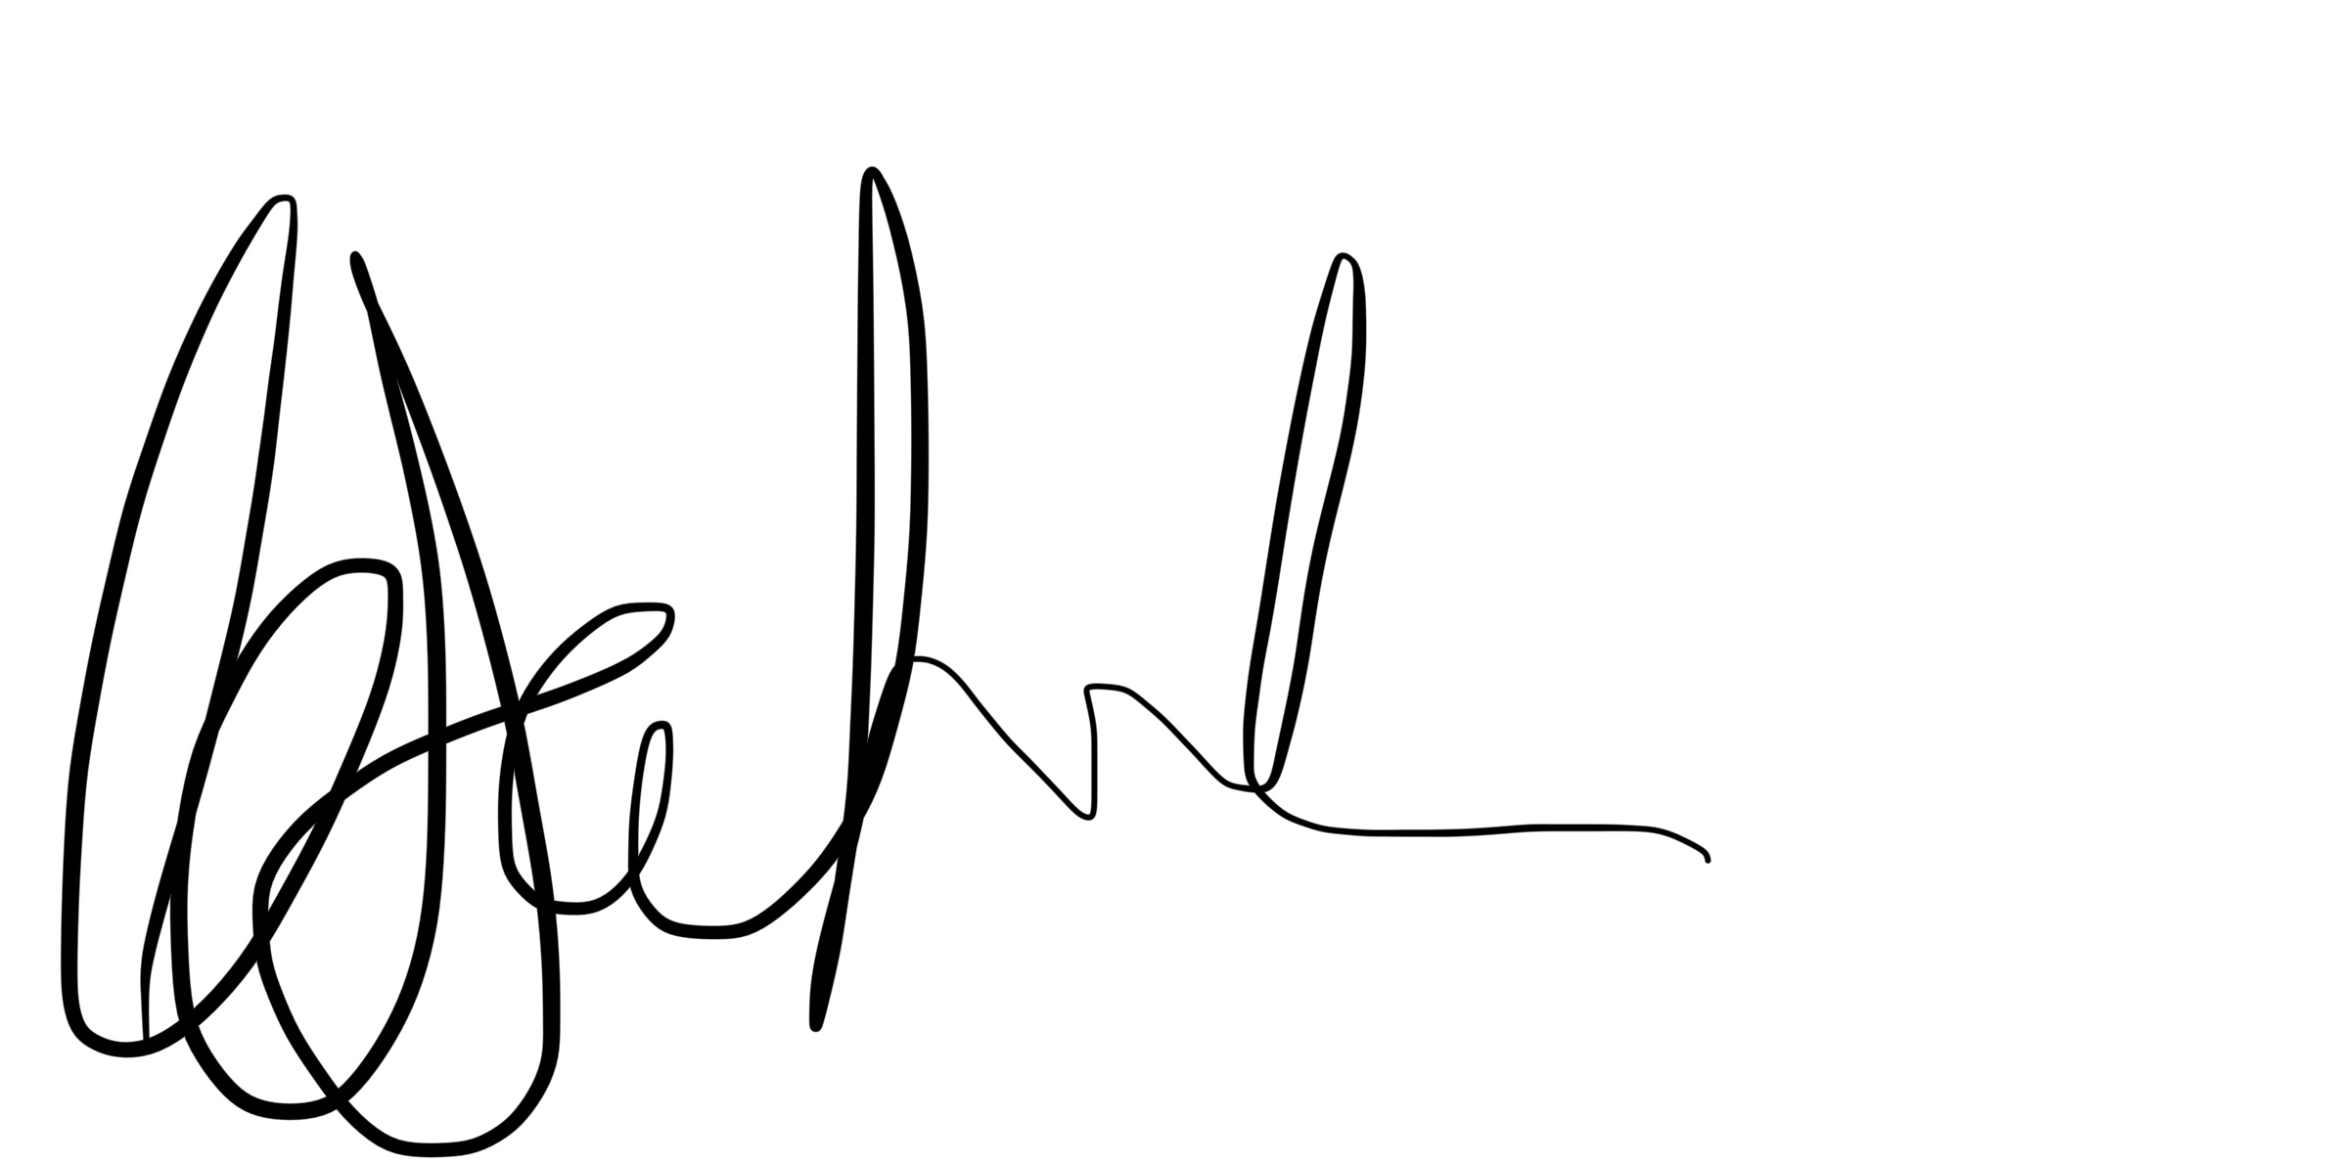
Client signature: ………………………………………………… Date: ………………………….

C SERFONTEIN

